231678
[Email address]
231678
AROOBA SHEHZADI
lab 01
VISUAL PROGRAMMING

TASK 1:
using System;
using System.Collections.Generic;
using System.ComponentModel;
using System.Data;
using System.Drawing;
using System.Linq;
using System.Text;
using System.Threading.Tasks;
using System.Windows.Forms;

namespace FirstWinFormsApp
{
public partial class Form1 : Form
{
public Form1()
{
InitializeComponent();
}

private void textBox1_TextChanged(object sender, EventArgs e)
{

}

private void button1_Click(object sender, EventArgs e)
{
string username = textBox2.Text;
MessageBox.Show("HELLO, "+username+"!");
}

private void label1_Click(object sender, EventArgs e)
{

}
}
}

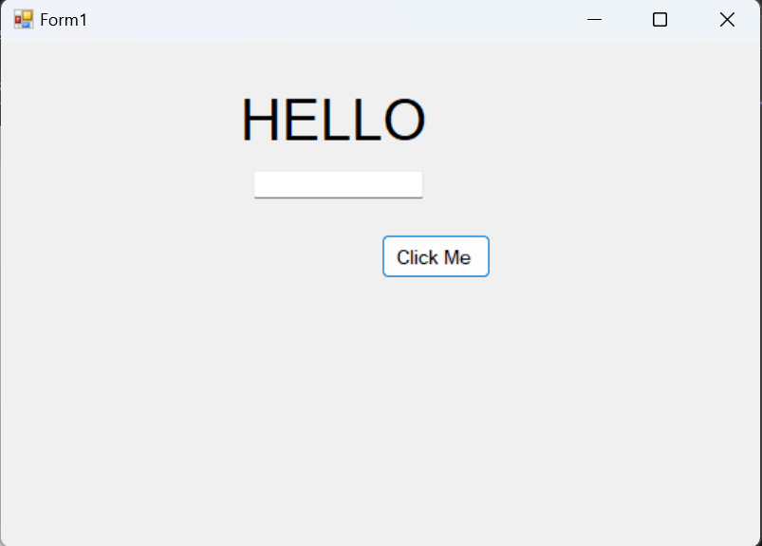

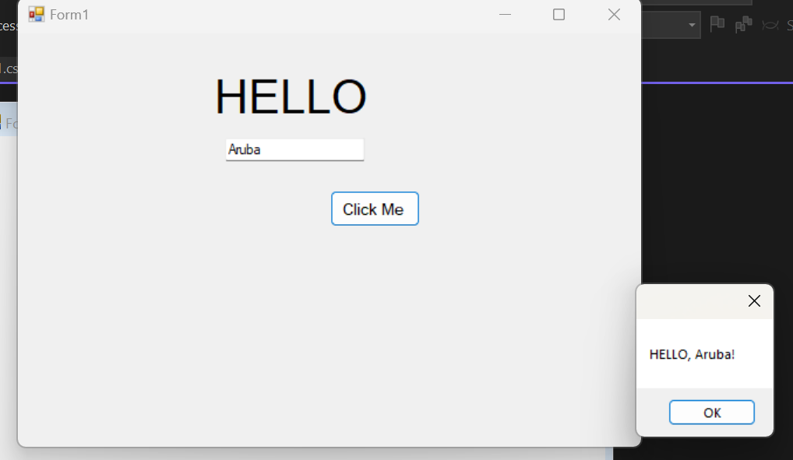
TASK 3:
using System;
using System.Collections.Generic;
using System.ComponentModel;
using System.Data;
using System.Drawing;
using System.Linq;
using System.Text;
using System.Threading.Tasks;
using System.Windows.Forms;

namespace FirstWinFormsApp
{
public partial class Form1 : Form
{
public Form1()
{
InitializeComponent();
}

private void textBox1_TextChanged(object sender, EventArgs e)
{

}

private void button1_Click(object sender, EventArgs e)
{
MessageBox.Show("Welcome to C# Windows Forms!");
}

private void label1_Click(object sender, EventArgs e)
{

}
}
}
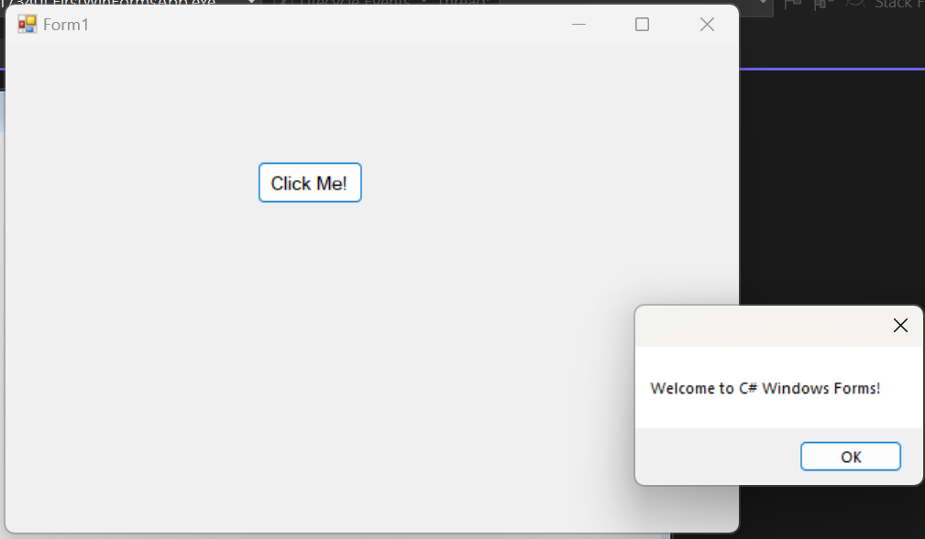
TASK 4:
using System;
using System.Collections.Generic;
using System.ComponentModel;
using System.Data;
using System.Drawing;
using System.Linq;
using System.Text;
using System.Threading.Tasks;
using System.Windows.Forms;

namespace simplecalculator
{
public partial class Form1 : Form
{
public Form1()
{
InitializeComponent();
}

private void textBox1_TextChanged(object sender, EventArgs e)
{

}

private void textBox2_TextChanged(object sender, EventArgs e)
{

}

private void button1_Click(object sender, EventArgs e)
{
double num1=Convert.ToDouble(textBox1.Text);
double num2=Convert.ToDouble(textBox2.Text);
double result=num1+num2;
labelResult.Text = result.ToString();
}

private void labelResult_Click(object sender, EventArgs e)
{

}

private void button2_Click(object sender, EventArgs e)
{
double num1 = Convert.ToDouble(textBox1.Text);
double num2 = Convert.ToDouble(textBox2.Text);
double result = num1 - num2;
labelResult.Text = result.ToString();
}

private void button3_Click(object sender, EventArgs e)
{
double num1 = Convert.ToDouble(textBox1.Text);
double num2 = Convert.ToDouble(textBox2.Text);
double result = num1 * num2;
labelResult.Text = result.ToString();
}

private void button4_Click(object sender, EventArgs e)
{
double num1 = Convert.ToDouble(textBox1.Text);
double num2 = Convert.ToDouble(textBox2.Text);
double result = num1 / num2;
labelResult.Text = result.ToString();
}

private void clearfiels_Click(object sender, EventArgs e)
{
textBox1.Text = "";
textBox2.Text = "";
labelResult.Text = "";
}
}
}

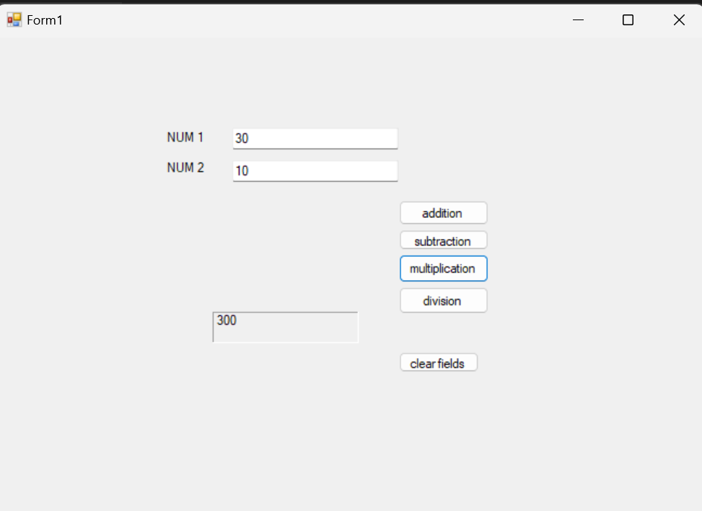
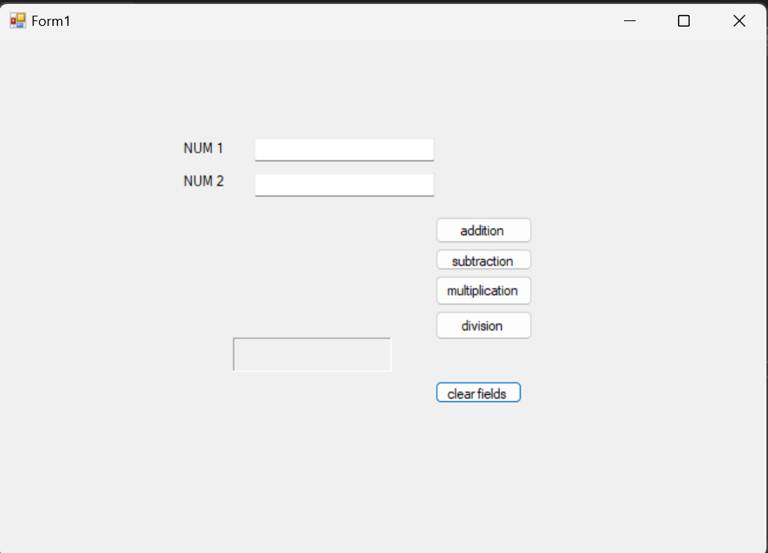
TASK 05:
using System;
using System.Collections.Generic;
using System.ComponentModel;
using System.Data;
using System.Drawing;
using System.Linq;
using System.Text;
using System.Threading.Tasks;
using System.Windows.Forms;

namespace simplecalculator
{
public partial class Form1 : Form
{
public Form1()
{
InitializeComponent();
}

private void button1_Click(object sender, EventArgs e)
{
this.BackColor = Color.Red;
}

private void button2_Click(object sender, EventArgs e)
{
this.BackColor= Color.Green;

}

private void button3_Click(object sender, EventArgs e)
{
this.BackColor= Color.Blue;

}
}
}

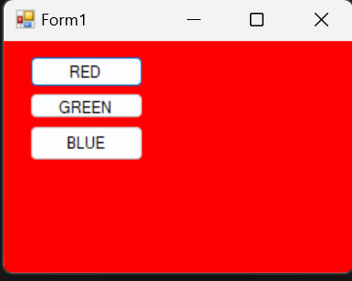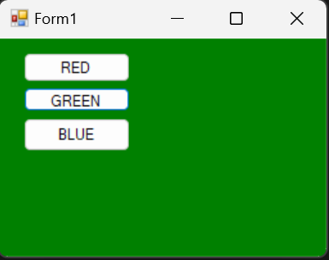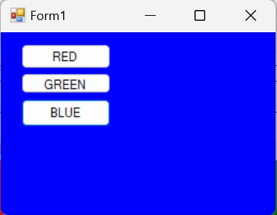
TASK 5
using System;
using System.Collections.Generic;
using System.ComponentModel;
using System.Data;
using System.Drawing;
using System.Linq;
using System.Text;
using System.Threading.Tasks;
using System.Windows.Forms;

namespace simplecalculator
{
public partial class btnLogin : Form
{
public btnLogin()
{
InitializeComponent();
}

private void button1_Click(object sender, EventArgs e)
{
if (textBox1.Text == "admin" && textBox2.Text == "1234")
{
MessageBox.Show("Login Successful!");
}
else
{
MessageBox.Show("Invalid Credentials");
}

}

private void textBox1_TextChanged(object sender, EventArgs e)
{

}

private void textBox2_TextChanged(object sender, EventArgs e)
{
textBox2.UseSystemPasswordChar = true;
}

private void button2_Click(object sender, EventArgs e)
{
textBox1.Clear();
textBox2.Clear();
}

private void radioButton1_CheckedChanged(object sender, EventArgs e)
{
// Show password when checked, hide it when unchecked
if (radioButton1.Checked)
{
textBox2.UseSystemPasswordChar = false; // Show password
}
else
{
textBox2.UseSystemPasswordChar = true; // Hide password
}
}

}
}

